
Assessment Cover Page
Student Full Name | Batjargal Tsetsegmaa
Student Number | 2026377
Module Title | Strategic Thinking
Assessment Title | CA 1 – Capstone Project Proposal
Lecturer/Supervisor | Taufique Ahmed
Assessment Due Date | 25-10-2026
Date of Submission | 21-09-2026

Declaration of AI Use — AI Fluency Framework
This assessment applies to CCT College Dublin's AI Fluency Framework — four interconnected competencies that ensure your engagement with AI is effective, efficient, ethical and safe: Delegation, Description, Discernment and Diligence. Full detail on what AI use is permitted for this assessment, and the evidence you must provide, is set out in your Assessment Brief.
Delegation  Setting goals and deciding whether, when and how to engage with AI. | Description  Effectively describing goals to prompt useful AI behaviours and outputs.
Discernment  Accurately assessing the usefulness of AI outputs and behaviours. | Diligence  Taking responsibility for what we do with AI and how we do it.
Adapted from the AI Fluency Framework (Dakan, Feller, Anthropic, 2025).

Filling Out the Cover Sheet
- Fill out the top section of the cover page with all the required information.
- Complete the Student Response column of the AI Declaration table in the appendix of this cover, evidencing your Delegation, Description, Discernment and Diligence.

AI competence | Reflective prompts (to students) | Lecturer expectations | Student response
Delegation  Deciding whether & when to use AI | Identify the specific tasks in this assessment where you chose to use AI, and explain your reasoning. Where did AI add value? Where did you decide not to use it, and why? | You may use AI to support your learning and development of the application. Clearly identify where you used AI and where you completed the work independently. | AI use: I used AI to select my project topic, correct grammatical and spelling mistakes in my writing, make a high level architecture diagram for the presentation. It helped me save time, understand the topic better, and develop my project idea. For example, it helped me explain in the introduction how employee attrition can affect businesses financially and lead to other negative consequences. I asked AI to translate really specific details on requiremts of project to understand clearly.  I independently developed the introduction, aim and objectives, scope, methodology, and project timeline. I also independently searched for and selected the dataset. AI helped me choose my project topic by connecting my work experience with the issue of employee attrition. I also read other students’ projects and compared them with my own to understand how to structure and improve my proposal. I made the final decisions about my project content and scope independently.
Description  How you prompted the AI | Include the exact prompts you used in your appendix (recorded on the AI Tools declaration). Reflect on how you communicated your goals to the AI — did you need to iterate or refine your prompts to get useful output? | You must provide the exact prompts and relevant AI outputs used during the development of your application. | I used AI to expand my ideas about employee attrition and understand the problems it causes for businesses. I refined my prompts when necessary to get clearer and more relevant information. Especially, I used AI mainly to express my ideas correctly in English and choose appropriate words for my project proposal.
Discernment  Evaluating what the AI produced | In your reflection, critically evaluate the AI output: what did you accept, modify, or reject — and why? Assess accuracy, relevance, and quality. You are responsible for verifying all AI-generated content before submitting. | You are responsible for checking, testing and understanding any AI-generated code or suggestions before using them in your work. | I reviewed the AI-generated suggestions and selected the information that was relevant to my employee attrition project. I accepted the main ideas about recruitment costs, training costs, reduced productivity, and the loss of experienced employees because they were relevant to my research topic. I modified some sentences to make them simpler and more suitable for my introduction. I did not use every suggestion because I wanted to focus on the most important problems related to employee attrition. I also checked the information against my research sources to ensure its relevance and accuracy.
Diligence  Responsibility for your AI use | Declare all AI tools used and cite them here. Briefly outline how you considered data protection, copyright, and ethical responsibilities when choosing what to input into any AI system. Unauthorised use is subject to CCT disciplinary procedures. | Declare all AI tools used. Do not enter personal, confidential or sensitive information into AI tools. Any external sources used should be appropriately referenced. | I used ChatGPT to help develop my project ideas, improve English grammar, simplify sentences, and clarify the problems caused by employee attrition.  I also checked relevant information and included references to external sources used in my project.

Investigating the factors that influence employee attrition
Introduction
Nowadays, employee attrition has become a major concern for businesses. One of the major challenges organisations face is employee retention. A high rate of employee turnover can increase recruitment and training costs, disrupt business operations, and lead to the loss of valuable institutional knowledge. According to McKinsey & Company (De Smet et al., 2021), more than 19 million workers in the United States have quit their jobs, indicating that employee attrition is a huge challenge for companies. Traditional methods such as exit interviews and employee surveys which provide limited insights since they focus on post-departure feedback , which is often too late for intervention. (Nistala, 2024) Therefore, identifying and forecasting factors affecting employee attrition is important for companies since it will help them avoid recruitment costs and improve the productivity of the company.
This project will identify and analyze factors that influence employee attrition using data analytics and machine learning techniques. The factors of interest in this project include business travel, education field, environment satisfaction, job satisfaction, monthly income, hourly rate, and overtime, as they relate to employees' decision to leave an organization. This research will involve analysis of employee-related data to find significant patterns and relationships between employee attrition. It will then be used to create a predictive model that estimates the probability of employees leaving an organization in the future. The findings of this project may help organizations make informed decisions, increase employee retention, and minimize employee turnover costs.
Problem definition
The key business problem addressed in this project is the difficulty of identifying which employee-related factors are most strongly associated with employee attrition. High employee turnover can increase recruitment and training costs, decrease productivity, and cause the loss of experienced workers. These issues can negatively impact a company's finance efficiency, worker retention, and long-term growth.
This project will use the employee dataset to determine the difference between employees who leave and those who stay in a given organisation. In particular, the project will investigate the relationship between employee attrition and certain variables. In this project, data analytics will be used to analyze the data for patterns and to identify the most significant features.
Further, predictive modelling will be used to calculate the probability that employees will leave the organisation based on the available data. This will help the company to predict potential workforce issues. Over the long term, this could save the company money in recruiting and training, improve productivity, better resource allocation and better financial performance.
Aim
The overall aim of this project is to analyse the factors associated with employee attrition using data analytics and machine learning techniques, and to develop a predictive model to estimate the likelihood of employees leaving an organisation.
Objectives
- To explore the employee dataset and check its data types, missing values, and important variables.
- To investigate how factors such as business travel, education field, job satisfaction, monthly income, hourly rate, overtime, and environment satisfaction are related to employee attrition.
- To use charts and summary statistics to compare employees who left the company with those who stayed.
- To build a machine learning model to predict whether an employee is likely to leave the company and evaluate how accurately it makes predictions.
- To explain the results and identify ways to improve the main factors associated with employee attrition.
Scope
Including in the project
Machine learning techniques will be used to analyse the data and make predictions about employee attrition.
- to clean the data and check for missing value
- to do statistical analyses and illustrate the statistical result by graph
- to investigate the factors related to employee attrition
- to develop a machine learning model and evaluate its performance
- to provide recommendations to help companies improve employee retention based on the results
Excluded from the Project
- to use real employee data which is based on specific organization
- to collect new real data directry from worker through survey
- to exclude guaranteeing 100% accurate predictions of employee attrition
Methodology
This project will investigate about the factors that associated with Employee Attrition based on synthetic dataset, and develop a maching learning model to predict whether employee is likely to leave a company.
- Data collection and source
- Data cleaning- checking missing values, data types
- Exploratory data analysis- understand dataset, identify the patterns,
- Predictive modelling
- Logistic Regression helps to understand the probability of employee leaving based on different variables, such as job satisfaction and overtime. Logistic regression is a supervised learning model for binary classification. (Iparraguirre-Villanueva et al., 2024)
- Decision Trees can be more flexibility, as they can model both linear and nonlinear relationships between employee characteristics and the risk of attrition. Its work by splitting data into branches based on key variables.
- Random Forest is an ensemble learning method that combines the predictions of multiple decision trees to produce a final prediction. It is machine learning algorithm that uses many decision trees to make better predictions. (GeeksforGeeks, n.d.)
- K-nearest Neighbors(KNN) can work on the employee attrition dataset, where an employee is classified into staying/leaving based on similatiry, such as education, remote working, and monthly income. This is a model that classifies data points according to their proximity to nearest neighbors. (Iparraguirre-Villanueva et al., 2024)
- Model Evaluation- Accuracy, Precision, Recall
- Results and Recommendations- explain the results and reasons that come from data analysis.
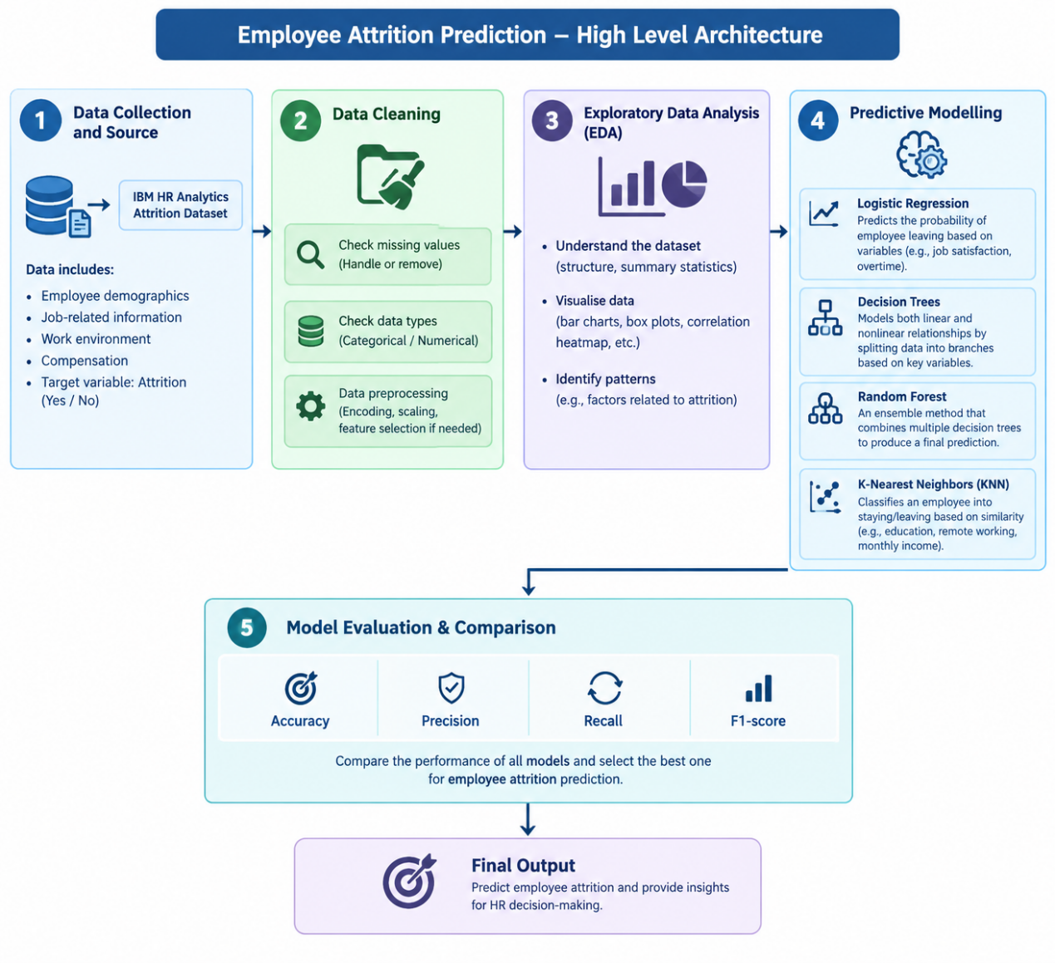

Data Sources
This project will use the IBM HR Analytics for Attrition dataset, downloaded from the Excel BI Analytics website. The dataset was generated using random logic in VBA and does not contain real human resources data. (Excel BI Analytics) There is 35 variables and 50.000 records. The analysis will focus on factors such as business travel, education field, environment satisfaction, job satisfaction, monthly income, hourly rate, overtime, age, and work-life balance.
Expected Deliverables
- Clean the dataset and prepare it for analysis.
- Analyse the factors related to employee attrition using charts and statistics.
- Develop a machine learning model to predict employee attrition.
- Compare the model results and select the most suitable model.
- Make recommendations based on the research findings.
- Complete the final project report and Python code.
Project Timeline
S1 | Project phase | W1 | W2 | W3 | W4 | W5 | W6 | W7 | W8 | W9 | W10 | W11 | W12
S1 | Select topic/dataset
S1 | Introduction, problem definition
S1 | Aim, objectives, scope
S1 | Methodology
S1 | Checking final word file
S1 | Choose sufficient data
S1 | Explore and understand the dataset
S1 | Data Cleaning
S2 | Data Exploration
S2 | Statistical Analysis
S2 | Data Visualisation
S2 | Report Writing

Ethical and Legal Considerations
This project will use synthetic data to protect individual privacy and avoid interfering with real organisations. The dataset will be used in accordance with its permitted terms of use and for academic purposes only. Data will be stored securely, and the results will be presented accurately and ethically.

Data source:
Verma, V.A. (2021) Downloads 22 – Sample CSV Files / Data Sets for Testing (till 5 Million Records) – IBM HR Analytics for Attrition. Excel BI Analytics. Available at: https://excelbianalytics.com/downloads-21-sample-csv-files-data-sets-for-testing-till-5-million-records-hr-analytics-for-attrition/ (Accessed: 23 October 2026).
References:
De Smet, A., Dowling, B., Mugayar-Baldocchi, M. and Schaninger, B. (2021) ‘Great Attrition’ or ‘Great Attraction’? The choice is yours. McKinsey & Company. Available at: https://www.mckinsey.com/capabilities/people-and-organization/our-insights/great-attrition-or-great-attraction-the-choice-is-yours (Accessed: 23 October 2026).
Nistala, V.K.S.M. (2024) Predicting Employee Attrition Using Machine Learning in Tech Industry: A Methodological Approach. Masters thesis. Dublin: National College of Ireland. Available at: https://norma.ncirl.ie/8761/1/venkatakameswarasaimaneeshnistala.pdf (Accessed: 23 October 2026).
GeeksforGeeks (n.d.) Random Forest Algorithm in Machine Learning. Available at: https://www.geeksforgeeks.org/machine-learning/random-forest-algorithm-in-machine-learning/ (Accessed: 23 October 2026).
Iparraguirre-Villanueva, O., Chauca-Huete, L., Prieto-Chavez, R. and Paulino-Moreno, C. (2024) ‘Employee attrition prediction using machine learning models’. Proceedings of the LACCEI International Multi-Conference for Engineering, Education, and Technology, 1(10). Available at: https://doi.org/10.18687/LACCEI2024.1.1.498 (Accessed: 23 October 2026).

Appendix : AI Tools Declaration
The promts that i used
Q:Help me choose a project topic related to my work experience. Employee attrition can be the real problem?
A: Yes, employee attrition can be a real business problem, and it can be a suitable topic for your data analytics capstone project.The important point is to explain how employee attrition affects an organisation and why data analytics and predictive modelling can help address it.
Q: choose the real problem in requirements, so can I choose the data that should be synthetic or real company data?
A: Yes, you can use synthetic data to investigate a real-world business problem, as long as you explain its relevance and limitations.
Q: Investigating the Factors that Influencing Employee Attrition Using Data Analytics how bout this topic name
A: Your title clearly represents your research topic. However, grammatically, “Factors Influencing” is more natural and academically appropriate in English.
My suggested title is:
Investigating the Factors Influencing Employee Attrition Using Data Analytics

Q: Tell me the more problems that caused by employee attrition except that I mentioned?
A: Employee attrition can also cause lower team morale, increased stress for remaining employees, delays in projects, reduced customer satisfaction, loss of team collaboration, and difficulties maintaining service quality.

Q: Employee attrition data is easy to find?
A: Yes, employee attrition datasets are relatively easy to find online, including publicly available synthetic datasets.

Q: Байгууллагуудын хувьд ажилтнуудаа тогтоон барих нь тулгарч буй том асуудлуудын нэг яалт ч үгүй мөн юм. Ажилтны ажлаас гарах урсгал ихсэх нь байгууллагын санхүү болон бүтээмжид шууд нөлөөлдөг. Тиймээс ажилтнуудын ажлаас гарах шалтгаануудыг судлан илрүүлж, таамагласнаар тогтвор суурьшилтай ажилтан бий болж, байгууллагын бүтээмж, санхүүгийн гарах урсгалыг багасгахад чухал хувь нэмэр болох юм. Translate to english
A: The ideas you have written are suitable for the Introduction section. The main ideas can be maintained while improving the wording to make it more academic in English.
Retaining employees is one of the major challenges faced by organisations. High employee attrition can have a significant impact on an organisation’s finances and productivity due to recruitment and training costs, as well as the loss of experienced employees. Therefore, investigating and predicting the factors that influence employee attrition is important for organisations. By identifying the key factors associated with employees leaving their jobs, organisations can develop effective employee retention strategies, improve workforce stability, increase productivity, and reduce costs. This project will use data analytics and predictive modelling to investigate the factors influencing employee attrition and support data-driven decision-making in human resource management.

Q: Since the objectives are already covered in the relevant section, do I need to mention them again in the Introduction?
A: Yes, but you do not need to repeat exactly the same information in the Introduction and Aim and Objectives sections. Each section has a different purpose.

Q: create high level architecture by the information that I gave

